
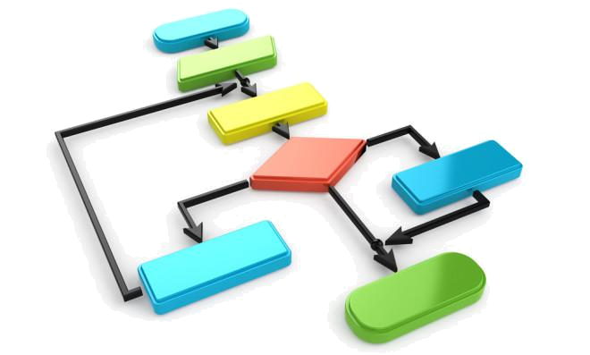

CHANGE MANAGEMENT TOOLKIT

Tips, tools, and techniques for leading a successful change initiative


VCA – Business Process Management Office (BPMO), Priya Sarran Central HR – Organizational Effectiveness, Delia Clark Central HR – Learning & Development, Kathy Mendonca


Change Management Toolkit

0 | P a g e
Table of Contents

How to Use this Toolkit 2

Why Change Management? 3

What happens if a Necessary Change Management Component is missing? 4

Change Management Pre-work 5

To Change Behavior – Direct the Rider 6

Case for Change Template 7

Compelling Vision Interview Template 8

Working with Your Sponsor Overview 9

Sponsor Expectation Tool 10

Stakeholder Analysis and Engagement Plan Overview 11

Stakeholder Analysis and Engagement Plan Template 15

Change Readiness Assessment (baseline) 16

Behavioral Change Plan 17

Team Communication Overview 19

Team Communication Plan 20

Manage Personal Transitions (resistance) 21

To Change Behavior – Motivate the Elephant 22

Transition Model (Bridges) 23

Change Process Model (Kubler-Ross) 24

Change Process Model – Indicators & Strategies (Kubler-Ross) 25

Core Values Exercise 27

Best Practices for Leading Change – What to Do 28

Best Practices for Leading Change – What NOT to Do 29

Develop Change Plan 30

To Change Behavior – Shape the Path 31

Implementation Strategies 32

Risk Assessment Template 33

Success Metrics Overview 35

Success Metrics Template 36

Feedback Strategy Overview 37

Feedback Strategy Options 38

Change Communications Plan Overview 40

Change Communications Plan Template 41

Change Communication Brief Template 45

Implement & Monitor the Change 46

To Sustain the Change – Keep the Momentum Going 47

Change Readiness Assessment (final check before pilot/big bang) 48

Monitor Metrics for Continuous Improvement 49

Change Management Toolkit

1 | P a g e

How to Use this Toolkit

Why is a change management toolkit necessary?


In the 21st century we are surrounded by constant innovation, technology enhancements, and a connection to a global network, all of which has created a new normal of perpetual change. As a way of handling the increased volume of change, a plethora of proven tools and techniques have been created to aid individuals in managing change. As a result of these tools and techniques being globally socialized and tested, the necessary components for effectively managing change are known. These proven tools and techniques have been reviewed and curated into this toolkit which contains those most appropriate for use at UC Berkeley.

Who is this toolkit for?


This toolkit is designed for any individual responsible for leading a change initiative of any size.

How to use this toolkit?


This toolkit begins with an introduction to the importance of change management and goes over the seven components necessary to effectively manage change. It is organized into four main sections:

- Change Management Pre-work

- Manage Personal Transitions (resistance)

- Develop Change Plan

- Implement & Monitor the Change.

Each of these sections contain a collection of tools and techniques which organize the work needed for the change initiative and they are best followed chronologically.

While a multitude of tools are provided, not all tools will be necessary for every change. When considering which tools to use, review the scope of the change identified in the Project Charter. For large scale initiatives, it is recommended that all tools be used in each section of the toolkit. For small to medium sized initiatives, at a bare minimum, the following tools should be used:

- Case for change template (page 7)

- Compelling vision Interview template (page 8)

- Change communication plan overview & template (pages 40-41)

- Change Readiness assessment (page 16)

- Manage Personal Transitions (resistance) Section (pages 21-29)

- Feedback Strategy Overview & Options (pages 37-38)

- Behavioral change Plan (page 17)

Change Management Toolkit

2 | P a g e

Why Change Management?

As a top-ranked public research university, UC Berkeley serves as a flagship institution when it comes to our bold and innovative initiatives. Change management is often the key component in driving the success of these ventures. As we know from our own experience, not all change initiatives are equally disruptive. Some will have a greater impact and be more challenging. Others may be barely noticeable.

Change can be bucketed into two main categories: Incremental and Transformational. Incremental change is easier to implement successfully. It is often based on the current state in order to improve the existing way of doing our work. It typically involves fewer changes and affects a small number of people. On the other hand, Transformational change is more difficult to implement, typically having only a 30% success rate. (Taking Stock survey by The Change Management Toolbook, February 2005) Why is that?

Things get more challenging when the change is Transformational because it is designed from a future state and involves a fundamentally new way of doing things. This typically involves significant culture change and affects a large number. The complexity involved in culture change is often why it is easier to change the change than it is to change the culture.

Culture is our values, beliefs, assumptions, and unwritten rules. These shape our behaviors and mindset as well as our performance. Individuals within an organization co-create the culture through conversations and by following behavioral norms. In addition to the overarching culture of an organization, individual subcultures often exist. Taking both of these into consideration for your particular initiative is necessary when determining how to approach a change for your area.

Since there are many complexities involved in executing a change initiative, both change management and project management components are required. Sometimes change management and project management are mistaken as one in the same…when actually they are two complimentary yet different disciplines. Both utilize formal processes, tools, and techniques to plan for the change, manage the change, and sustain the change. While change management focuses on ensuring the support of the people, project management focuses on the work tasks to be executed. Coupled together, proactive change management and project management will lead to the actualization of the benefits of the change initiative.

The one common denominator to achieve success for all change initiatives is people. According to Chip and Dan Heath, authors of Switch, peoples’ brains have two independent systems at work at all times: the rational side (is reflective, it deliberates, analyzes, and looks to the future), and the emotional side (is instinctive, feels pleasure and pain). Think of the rational side of the brain as the Rider and the emotional side of the brain as an Elephant. The Rider’s strength is to think and to plan. Without a plan there is no path to get things done. The Elephant’s strength is emotion. Without emotion there is no motivation (no energy) to get things done.

To change behavior (our own or someone else’s), we must do three things:

- Direct the Rider – make the destination crystal clear


The Rider has their own issues. A Rider likes to contemplate and analyze information before deciding on a direction. When a Rider isn’t sure exactly which direction to go, they lead the Elephant in circles. Often, what looks like resistance is actually lack of clarity.

- Motivate the Elephant – make people feel the need for change

When an individual’s six-ton Elephant is not in agreement with the direction their Rider wants to go, the Rider is going to lose. The Rider may get their way temporarily, through close monitoring and exerting self-control, but in the long term the Elephant will ALWAYS overpower the Rider. Why? Self-control is an exhaustible resource. Often what looks like resistance is actually exhaustion. Motivation provides the energy the Rider needs to maintain self-control; a lack of motivation may doom a change effort.


- Shape the Path – make the required changes specific


To direct the Rider and motivate the Elephant, we need to shape the Path by focusing the situation, including the surrounding environment, to make the change more likely. Being specific narrows the focus, so the Elephant and the Rider are more likely to stay traveling together toward the goal. Often, what looks like resistance is actually lack of direction.

Heath, Chip, and Dan Heath. Switch: How to Change Things When Change Is Hard. Thorndike Press, 2011

Change Management Toolkit

3 | P a g e

What happens if a Necessary Change Management Component is missing?

Industry statistics show that only 30% of organizational change initiatives are successful. For a change initiative to be regarded as successful, the desired objectives of the effort must be fully realized. The reason 70% of change initiatives fail is because organizations do not engage in effective change management. There are seven necessary components of change management. If any component is neglected, the result will be a less than optimal achievement of the initiatives goals. The below graphic illustrates the seven components required for successful change management and indicates specific consequences that occur when a component is missing. To assist you in proactively addressing each component, relevant remedies from the Toolkit are provided.
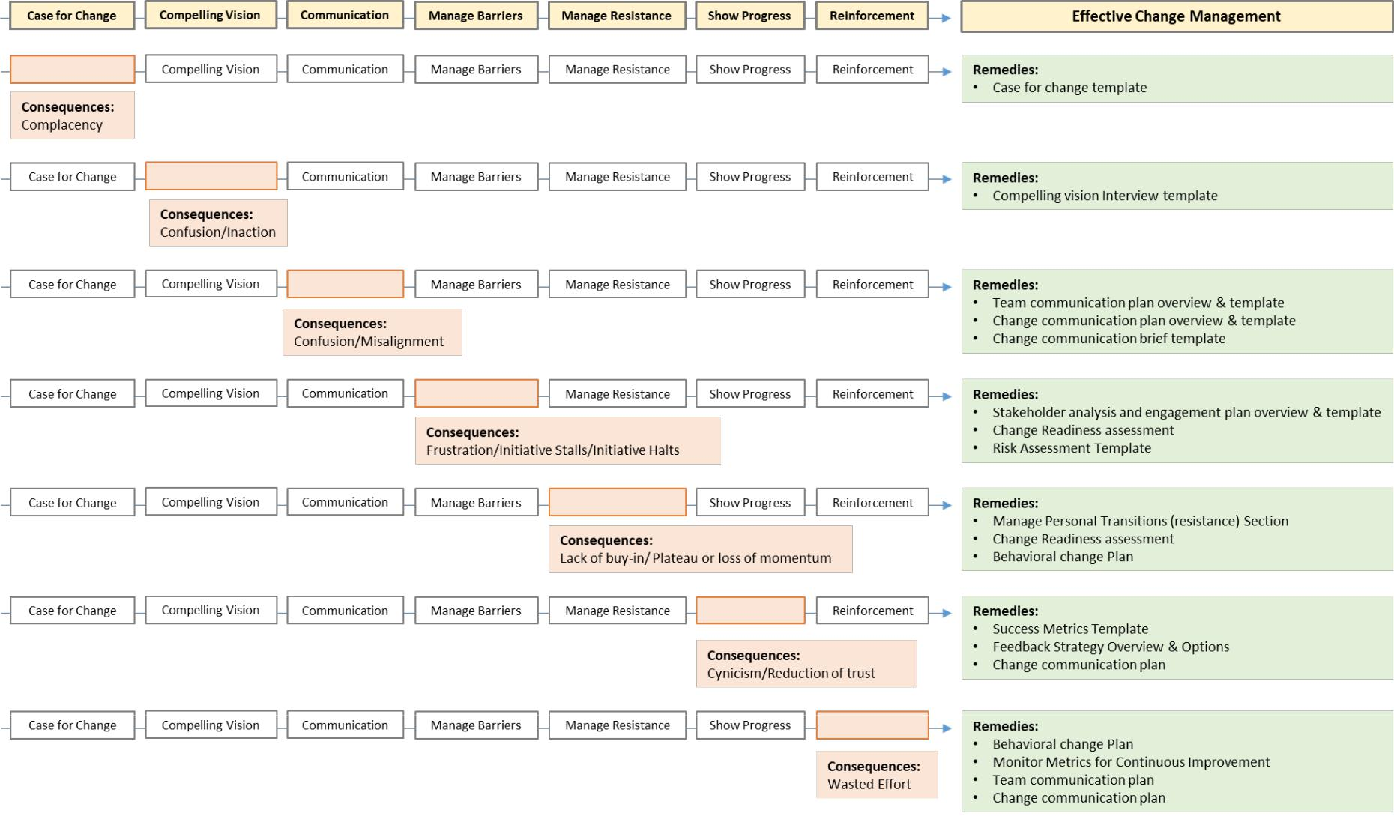

Adapted from: Linkage, Inc. “Leading Change and Managing Transitions.” Leading Change and Managing Transitions, 2015, pp. 8–11’

Change Management Toolkit

4 | P a g e

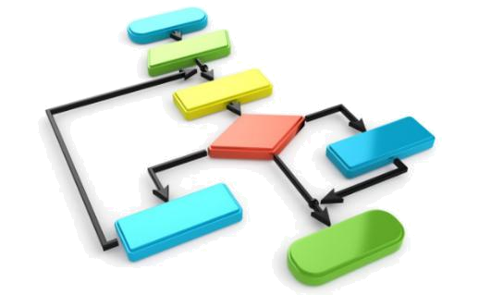

Change Management Pre-work
To Change Behavior – Direct the Rider

Case for Change Template

Compelling Vision Interview Template

Working with Your Sponsor Overview

Sponsor Expectation Tool

Stakeholder Analysis and Engagement Plan Overview

Stakeholder Analysis and Engagement Plan Template

Change Readiness Assessment (baseline)

Behavioral Change Plan

Team Communication Overview

Team Communication Plan

Change Management Toolkit

5 | P a g e
To Change Behavior – Direct the Rider

Think of the rational side of an individual’s brain as the Rider. The Rider’s strength is to think and to plan. A Rider likes to contemplate and analyze information before deciding on a direction. When a Rider isn’t sure exactly which direction to

go, they lead the emotional side of an individual’s brain (the Elephant) in circles. Often, what looks like resistance is actually lack of clarity.

Ways to Direct the Rider - Make the Destination Crystal Clear

Find the Bright Spots:

In situations requiring change, the Rider sees problems everywhere which may result in “analysis paralysis”. To make progress, direct the Rider toward workable solutions by finding and analyzing exceptions to the current problem. These “bright spots” point directly to solutions that will work in the current environment. These solutions can then be implemented as quick wins which will provide direction to the Rider and hope/motivation to the Elephant.

Script Critical Moves:

Decisions fall under the purview of the Rider. The more choices available to the Rider, the more ambiguous the path. An ambiguous path creates uncertainty, which makes the Elephant anxious. An anxious Elephant wants to stay on the path of the “status quo” rather than change to an uncertain path. The “status quo” is comfortable and reduces the Elephant’s anxiety. This means the Rider will have to constantly exert self-control to keep the Elephant on the uncertain path. To create successful change, ambiguous goals must be translated into concrete behavioral goals. Overtime, these defined behaviors become instinctive requiring less self-control from the Rider.

Point to an All or Nothing Destination:

It is necessary to provide the Rider with a near-term vivid picture of an all or nothing goal which shows what could be possible. Describing a compelling destination prevents the Rider from getting lost in analysis. Instead, the Rider starts figuring out how to get to the goal. This also shows the Elephant why the journey is worthwhile, without giving the Elephant any wiggle room to rationalize failure.

 CALL TO ACTION

Use all of the templates and tools provided in this section (Change Management Pre-work) to direct the Rider in relation to your change initiative.

Heath, Chip, and Dan Heath. Switch: How to Change Things When Change Is Hard. Thorndike Press, 2011.

Change Management Toolkit

6 | P a g e

Case for Change Template

The Case for Change Template is a tool that provides the Change Manager with one place to capture all the reasons a change needs to occur. Information to complete this template will be pulled from existing documents: Scope of Work, Project Charter, and relevant background information provided by the Sponsor.

Information on this template will be used to craft communications for each relevant audience impacted by the change.

To reveal the reasons for the change answer the following questions.

Background
What current problems
need to be solved?

How did we get here?

Current State

Where are we now?

Why is what we’re doing
currently not working?

What opportunities are
being missed?

Risks of Not Taking Action

What future problems are
anticipated if no action is

taken? What is the impact

to the organization?

Benefits of Taking Action
What are the benefits of

making the change?

What is the impact to the

organization?

Audience:

- Tailor the Case for Change message to the audience

- Narrow focus to 3-5 specific (most compelling) things that will resonate with that audience Sponsor
Process Owner(s) Sub-process Owner(s)
Directors/Managers of impacted employees Impacted Employees
Customers

Adapted from Linkage and Bain & Company

Change Management Toolkit

7 | P a g e

Compelling Vision Interview Template

The Compelling Vision Interview Template is a tool that provides the Change Manager with probing questions to discuss with the Project Sponsor. Answers to these questions will be used to craft communications for each relevant audience impacted by the change.

To discover the Sponsor’s vision for the change discuss and answer the following questions.

Organizational Goal
What do we hope to

achieve?

Organizational Benefits

How will things be better?

Impact to Stakeholders

Expected benefits?

Impact to Stakeholders
Potential consequences or

impacts?

Audience:

- Tailor the Compelling Vision message to the audience

- Put yourself in the shoes of your stakeholders – what will be inspiring to them? Sponsor
Process Owner(s) Sub-process Owner(s)
Directors/Managers of impacted employees Impacted Employees
Customers

Adapted from Bain & Company

Change Management Toolkit

8 | P a g e

Working with Your Sponsor Overview

To ensure actively engaged Sponsorship for a change initiative it is imperative to

To achieve the most impactful results of a change initiative a strong and active Sponsor is imperative. To ensure a Sponsor is actively engaged they must be educated on their role. The most impactful sponsors will:

- Serve as a champion for the change initiative
- Review and approve the Project Charter
- Secure resources for the project including budget and team member time
- Regularly review project progress and performance
- Approve necessary adjustments based on implementation performance results
- Attend project kick-offs and closing
- Broadly communicate: personal commitment to change, key milestone achievements, celebrate project successes
- Review pre and post implementation metrics to evaluate realized benefits of change initiative

The below outlines how to work with the Sponsor throughout the lifecycle of a change initiative:

YOUR RESPONSIBILITIES WHEN WORKING WITH THE SPONSOR

Pre-Implementation

- Collaborate with Project Sponsor to create Project Charter and obtain go/no-go decision

- Review with the Sponsor items listed on the Sponsor Expectation Tool for each phase of the project and obtain their agreement for assuming these responsibilities. Note: If the Sponsor is unable to commit to all described responsibilities, determine workarounds with the Sponsor for who will undertake these tasks (e.g. Steering Committee).

- Discuss with the Sponsor what is most critical and what can flex for the Project Plan (scope, time or resources)

- Agree to Sponsor’s preferred cadence and expected content for progress updates

- Ensure Sponsor can attend pre-implementation meeting with a personal commitment message

Note: If a project has multiple Sponsors, your goal is to ensure each Sponsor has an equal voice. To do this, conduct a meeting where all sponsors and yourself are in attendance to gain alignment of project vision, objectives and scope. Then establish ongoing working agreements with the use of a RACI which may be supplemented with Gradients of Agreement, Project Charter objectives and risk logs if necessary.

Implementation

- Refresh the Sponsor on their commitment by reviewing items listed on Sponsor Expectation Tool for the Implementation phase
Note: If the Sponsor is unable to commit to all described responsibilities, determine workarounds with the Sponsor for who will undertake these tasks (e.g. Steering Committee).
- Ensure Sponsor can attend implementation kick-off to publically acknowledge the work done to date and recognize individuals who were instrumental in the project’s launch
- Based on agreed upon cadence, provide performance updates to the Sponsor indicating project successes and opportunities for improvement
- Work with the Sponsor to iterate the project as necessary until desired results are achieved

Post-Implementation

- Refresh the Sponsor on their commitment by reviewing items listed on Sponsor Expectation Tool for the Post-Implementation phase
Note: If the Sponsor is unable to commit to all described responsibilities, determine workarounds with the Sponsor for who will undertake these tasks (e.g. Steering Committee).
- Ensure Sponsor can attend project close-out to discuss lessons learned and provide official sign-off for project closure

- Proactively discuss with Sponsor ongoing sustainability of change initiative

Change Management Toolkit

9 | P a g e

Sponsor Expectation Tool

Effective project sponsorship is essential to the success of a change initiative. The executive sponsor is accountable for achieving the initiative’s expected realized benefits. The project sponsor serves as the primary link between the project work team and executive leadership. This involves acquiring the necessary organizational support and facilitating strategic decision making to ensure a successful project outcome.

Throughout the lifecycle of the change initiative (pre-implementation, implementation, post-implementation) an effective sponsor must actively engage in the following activities:

Ensure | Ongoing | Gain | Arrange | Facilitate | Provide | Build | Effective
Alignment | Communication | Commitment | Resources | Problem Solving | Support | Sustainability | Sponsorship

The below outlines the responsibilities of an effective sponsorship throughout the lifecycle of a change initiative:

SPONSOR RESPONSIBILITIES

Pre-Implementation | Implementation | Post-Implementation
☐ Ensure alignment with strategic goals | ☐ Delegate decision making authority as appropriate if | ☐ Broadly communicate and celebrate realized benefits
☐ Assess organizational readiness based on | iterations are necessary | and lessons learned
existing commitments | ☐ Kick-off project implementation launch by publically | ☐ Attend lessons learned session and provide official
☐ Create and lead Steering Committee (if needed) | acknowledging work done for the change initiative | sign-off for project closure
☐ Contribute to Project Charter & provide sign-off for | ☐ Receive regular status updates and provide feedback | ☐ Sustain realized benefits by ensuring people and
go/no-go decision | ☐ Spearhead ongoing executive level communications | processes are in place for long term stability
☐ Communicate expected project benefits to impacted | and Steering Committee updates
stakeholders | ☐ Celebrate key milestones with Project Team
☐ Delegate decision making authority as appropriate | ☐ Communicate key milestones to impacted
☐ Champion project pre-implementation kick-off with a | stakeholders
personal commitment message
☐ Serve as point person for escalated issues
☐ Approve Project Plan and secure project resources
☐ Attend regular status updates and provide feedback
to prevent scope creep and course correct if needed

Change Management Toolkit

10 | P a g e

Stakeholder Analysis and Engagement Plan Overview

What is a Stakeholder?

A stakeholder is a person who has a vested interest in something and who is impacted by and cares about how it turns out. Refer to your COPIS, created during the process mapping phase of the project, as it provides a starting list of stakeholders.

Potential Stakeholders:

- People who can exert influence or pressure on your change

- People responsible for creating your change

- People who can choose to use or not use the results of your change

- People who will ultimately benefit from the work of your change

Stakeholders Types:
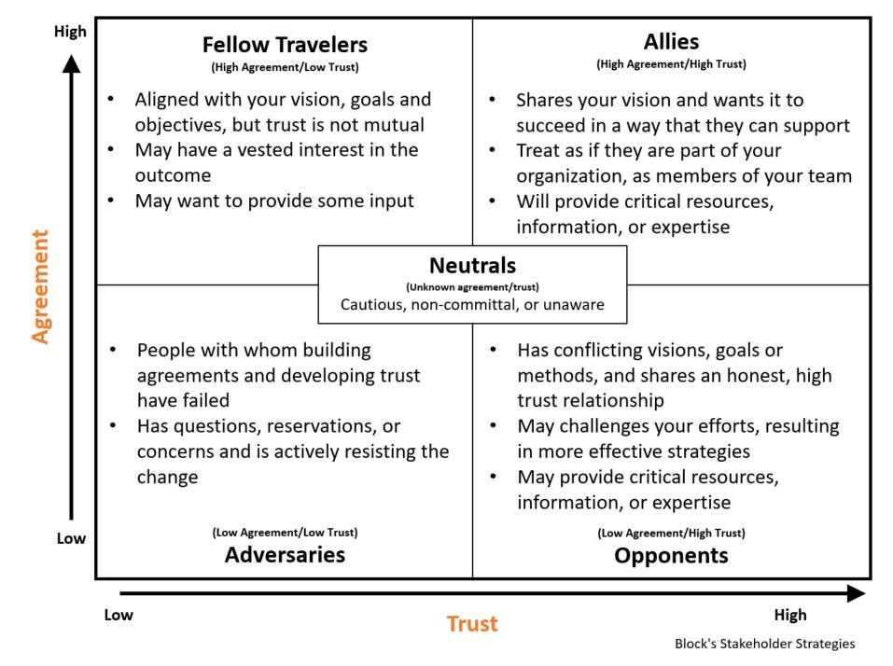

Change Management Toolkit

11 | P a g e

Identify each of your stakeholders into their appropriate types:

List Your Allies

List Your Opponents

List Your Fellow Travelers

List Your Neutrals

List Your Adversaries

Change Management Toolkit

12 | P a g e
Strategy for engaging each Stakeholder Type:

Once your stakeholders are identified into the appropriate type, it is a best practice to prioritize stakeholder engagement in the following order:

- Allies,
- Opponents
- Fellow Travelers
- Neutrals

- Adversaries

This prioritization strategy ensures the highest level of ongoing support for the change effort.

Stakeholder Approaches:

Listed below are various approaches for each Stakeholder Type to either maintain or shift each stakeholders’ level of commitment.

Allies (High Agreement/High Trust)

An approach for Maintaining Agreement and Trust
Goal: Affirm agreement
- Reaffirm the quality of the relationship
- Acknowledge any doubts and vulnerability you have with respect to your vision and project

- Discuss their issues or concerns with your project
- Ask them for advice and support
- Achieve understanding on their role and responsibilities
- Confirm their commitment to support your project

Fellow Travelers (High Agreement/Low Trust)

An approach for Maintaining Agreement and Increasing Trust
Goal: Build trust
- Reaffirm agreement by reiterating the value and importance of their support of your project
- Acknowledge any caution that exists
- Make it clear you are not expecting them to get actively involved
- Ask them how they would like to be updated on the project going forward

Opponents (Low Agreement/High Trust)

An approach for Shifting Commitment and Maintaining Trust
Goal: Build agreement
- Reaffirm the quality of the relationship
- Identify their particular skills and talents and how these connect to your project
- State your position (case for change, vision for change, benefits to them)
- State what you think their position is in a neutral way
- Extend a personal invitation for them to get involved with your project
- Engage in problem-solving so that you build something together
- Confirm their commitment to support your project

Change Management Toolkit

13 | P a g e

Adversaries (Low Agreement/Low Trust)

An approach for Shifting Agreement and Increasing Trust
Goal: Minimize threat to your project
- Estimate the impact on your project if this person is not on board
- Identify individuals who can educate you about this person, their issues and concerns
- State your position (case for change, vision for change, benefits to them)
- Ask questions that respectfully uncover root cause of their resistance
- State what you think their position is in a neutral way

- Identify your own contribution to the lack of trust that exists
- End the meeting with your plans and no demands
- If you are going to go around them or over them, tell them your plans
- Let go; the more you try to convert and pressure them, the more entrenched they will become in their position

Neutrals (Unknown Agreement and Unknown Trust)

An approach for Determining Agreement and Level of Trust
Goal: Educate and determine their position
- State your position (case for change, vision for change, benefits to them)
- Ask where they stand
- Ask what it would take for them to support your project
- Extend a personal invitation for them to get involved with your project

Adapted from Katherine Mitchell, University of California, Berkeley based on The Empowered Manager: Positive Political Skills at Work by Peter Block 1991

Change Management Toolkit

14 | P a g e

Stakeholder Analysis and Engagement Plan Template

Assess the level of commitment of each stakeholder and determine the actions needed to enhance agreement and trust.

- List all stakeholders identified above for your proposed change

- Describe your perception of their current understanding

- Place an “X” in the column that denotes their current Stakeholder Type

- Place a “●” in the column to denote the desired Stakeholder Type

- Describe the desired understanding you would like them to have

- Based on their current Stakeholder Type, cut and paste the approach provided in the Stakeholder Approaches section to develop an action plan for engaging with the stakeholder

 | Current Understanding |  |  |  |  |  | Desired Understanding | Discussion Approach
Stakeholder | (Describe stakeholder’s | Neutrals | Adversaries | Fellow | Opponents | Allies | (Describe the desired | (List the elements of
Stakeholder | current understanding of |  |  |  |  |  | understanding for each | the approach you plan
 |  |  |  | Travelers
 | the project and any |  |  | Travelers |  |  | stakeholder to ensure | to use with the
 | needs/concerns) |  |  |  |  |  | successful adoption) | stakeholder)
Adapted from Linkage

Change Management Toolkit

15 | P a g e

Change Readiness Assessment (baseline)
Use the below assessment to assess each team(s) and/or stakeholder(s) readiness for the change.

☐ Team : ___________________________ ☐ Stakeholder: ___________________________

 |  | Questions to Assess Change Readiness |  |  |  | Yes |  |  | Partial |  |  | No
 |  | (Awareness) Does your team or does your stakeholder understand…
 | 1. |  | the problems inherent in the current situation?
 | 2. |  | the opportunities that are being missed if the change doesn’t happen?
 | 3. |  | what is trying to be achieved?
 | 4. |  | how things will be better?
 | 5. |  | how the change will impact their area of work?
 | 6. |  | what their role will be in the future state?
 |  | (Desire) Does your team or does your stakeholder…
 | 1. |  | know that management is aligned with the change efforts?
 | 2. |  | feel their concerns, questions, and needs are being heard?
 | 3. |  | feel hopeful about the future?
 | 4. |  | see value in the change?
 | 5. |  | believe a well thought out strategy is being put in place to achieve the change?
 |  | (Knowledge) Does your team or does your stakeholder… (skills, informational, training)
 | 1. |  | have the necessary information, knowledge and skills to successfully fulfill their role?
 | 2. |  | know where to go for additional information about the change?
 | 3. |  | know what campus resources are available to support the personal side of change?
 | 4. |  | know what success looks like?
 | 5. |  | have a plan to achieve success?
 | 6. |  | know which behaviors will need to change?
 |  | (Ability) Does your team or does your stakeholder… infrastructure (systems, tools)
 | 1. |  | believe that the organization has provided appropriate resources (time, staff, information,
 |  |  | etc.) to support the anticipated change?
 | 2. |  | have the necessary systems, processes, and policies in place?
 | 3. |  | have the ability to execute the new behaviors required for the change?
 | 4. |  | know how to perform the required tasks?
 |  | (Reinforcement) Does your team or does your stakeholder…
 | 1. |  | view management as a resource for removing/overcoming barriers?
 | 2. |  | have mechanisms in place to reinforce the required behaviors?
 | 3. |  | have metrics in place to assess the ongoing effectiveness of the change?
 |  | Total
 |  |  |  |  |  |  | Change Management Toolkit

16 | P a g e

Behavioral Change Plan

To achieve successful implementation, changes in individual behaviors are required. Behavioral changes cannot be left to chance; they must be proactively planned for.

A behavioral change plan defines what success looks like, so it can be measured after the change is implemented. The most successful behavioral change plans look at the:
- Behaviors that need to change

- Systems, processes, and procedures that need to be in place to ensure success

- Other preparation activities required (e.g. training)

- Consequences necessary to sustain behavioral change

Using the questions below, a behavioral change plan is created by the team, for the team, to ensure sustained behavioral change. The leader creates an initial draft of the plan which is distributed to the team to obtain feedback. The team’s feedback is then incorporate into a revised plan in order to achieve buy-in prior to implementation.

Draft Plan Obtain Feedback Revise Plan Implement Plan

- What behaviors need to change?

________________________________________________________________________________________________________
________________________________________________________________________________________________________
________________________________________________________________________________________________________
________________________________________________________________________________________________________
________________________________________________________________________________________________________
________________________________________________________________________________________________________

- What does success look like? How will you measure it?

________________________________________________________________________________________________________
________________________________________________________________________________________________________
________________________________________________________________________________________________________
________________________________________________________________________________________________________
________________________________________________________________________________________________________
________________________________________________________________________________________________________

- What knowledge, skills, and abilities are needed to ensure new behaviors?

________________________________________________________________________________________________________
________________________________________________________________________________________________________
________________________________________________________________________________________________________
________________________________________________________________________________________________________
________________________________________________________________________________________________________
________________________________________________________________________________________________________

- What systems and tools are needed to support the behavior change?

________________________________________________________________________________________________________
________________________________________________________________________________________________________
________________________________________________________________________________________________________
________________________________________________________________________________________________________
________________________________________________________________________________________________________
________________________________________________________________________________________________________

Change Management Toolkit

17 | P a g e

Behavioral Change Plan, cont.

- What new policies, procedures, and/or processes are needed to support the behavior change?

________________________________________________________________________________________________________
________________________________________________________________________________________________________
________________________________________________________________________________________________________
________________________________________________________________________________________________________
________________________________________________________________________________________________________
________________________________________________________________________________________________________

- What training is needed to support the behavior change?

________________________________________________________________________________________________________
________________________________________________________________________________________________________
________________________________________________________________________________________________________
________________________________________________________________________________________________________
________________________________________________________________________________________________________
________________________________________________________________________________________________________

- What organizational assistance is available to emotionally support the employee?

________________________________________________________________________________________________________
________________________________________________________________________________________________________
________________________________________________________________________________________________________
________________________________________________________________________________________________________
________________________________________________________________________________________________________
________________________________________________________________________________________________________

- What reinforcements/consequences need to be in place to sustain behavior change?

________________________________________________________________________________________________________

________________________________________________________________________________________________________

________________________________________________________________________________________________________

________________________________________________________________________________________________________

________________________________________________________________________________________________________

________________________________________________________________________________________________________

Adapted from Bain & Company

Change Management Toolkit

18 | P a g e

Team Communication Overview

To achieve successful implementation, ongoing team communication is required. Communication must be proactively planned for and scheduled.

During times of change it is not uncommon for leaders to experience the following frustrating scenario:

As the manager, I feel like I have communicated clearly and frequently about the current changes, the business plan to address the changes, and the need to move forward. However, the large majority of my team seems confused about any possible changes and at least one staff member has blamed me for not giving the staff enough information.

Leaders often wonder… Why does this happen?

We know from brain imaging research, that we can’t think cognitively very well when we are emotional. The deductive reasoning area of our brain actually shrinks! When anxiety and fear are cumulative, our ability to function actually becomes impaired. This is true for us and for our employees. As supervisors, not only do we need to take steps to address our own emotions around the change, but we need to provide resources, be available to our employees, and role model self-care

The reason we communicate extensively during change is to ensure that everyone is hearing the same message, understands the new direction, and how their work and behaviors will be impacted by it. Something to keep in mind is…when people are under stress, their ability to process information is reduced by 80%.
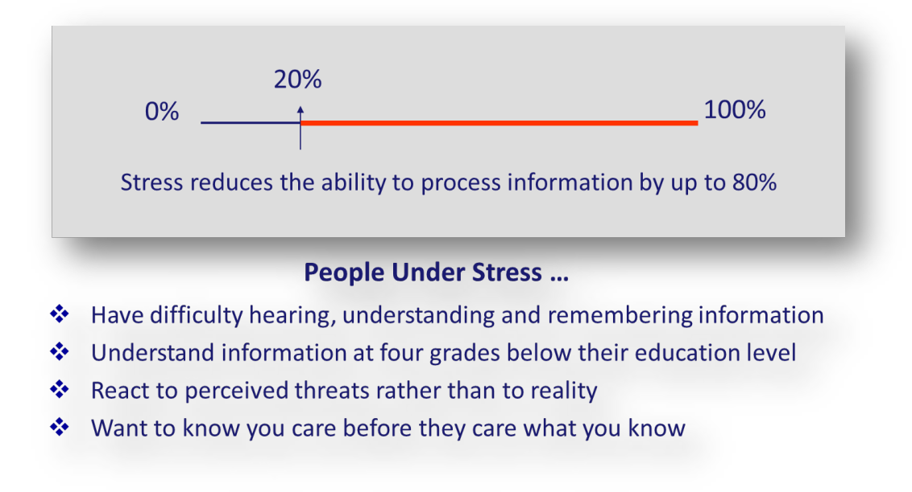

Communicating Organizational Change: Information Technology meets the Carbon-Based Employee Unit, Joseph G. Wojtecki, Jr., and Richard G. Peters, Center for Risk Communication, 2000

Change Management Toolkit

19 | P a g e

Team Communication Plan

The goal of change communication is to facilitate sustained realization of the change goal by recommitting people along the way. Keep in mind as you are communicating that people have a limited capacity to absorb information under stress. This is why you simply cannot communicate too much.

Type of Meeting | Purpose of Meeting |  |  | What to Communicate
Initial Group | • | Listen and encourage dialogue specific |  | When building commitment, begin by reiterating the
Meetings |  | to the proposed change |  | global organizational message about the change (both
 | • | Deliver change message |  | Case and Vision). Then provide specific information about
 |  | o | Case for change | how this change will impact the team’s work. This helps
 |  | o Vision for the future |  | those affected learn and understand what actions are
 |  | o Explain how the team’s work |  | required of them to actualize the change and achieve its
 |  |  | will be impacted by the larger | desired outcomes.
 |  | o | organizational change | Throughout the lifecycle of the change, communicate
 |  | o | What is/isn’t changing | Throughout the lifecycle of the change, communicate
 | • Address issues, concerns and ideas |  |  | constantly and continue to provide opportunities for the
 | • Review initial draft of the team specific |  |  | team to raise concerns and provide input. During times of
 |  | Behavioral Change Plan |  | change, leaders often feel they have communicated
 | • | Explain next steps: |  | excessively, while employees believe they haven’t
 |  | o | Upcoming 1:1s | received enough communication. It is critical for leaders
 |  | o Creation of work team to |  | to understand that during times of change employees are
 |  |  | provide feedback on | under a great deal of stress. Physiologically, stress reduces
 |  |  | Behavioral Change Plan | people’s ability to process information by up to 80%.
 | • Reference Best Practices for |  |  | Therefore, if you think you have communicated enough,
 |  | Communication* |  | communicate 10X more and then it may actually be
 |  |  |  | enough.
Regularly | • | Surface and address individual issues |  | In addition to frequent communication, it is also
scheduled |  | related to the proposed change |  | In addition to frequent communication, it is also
scheduled |  |  |  | important to use both group and 1:1 meetings as an
1:1 Meetings | • | Check-in on each individual’s |  | important to use both group and 1:1 meetings as an
1:1 Meetings | • |  |  | opportunity to ascertain each individual’s level of
 |  | commitment to the change |  | opportunity to ascertain each individual’s level of
 |  |  |  | commitment for the proposed change. For those who
 | • Reference Best Practices for |  |  | commitment for the proposed change. For those who
 |  |  |  | aren’t fully committed, use 1:1 meetings to
 |  | Communication* |  | aren’t fully committed, use 1:1 meetings to
 |  |  |  | discover/discuss what would move the person further
 |  |  |  | towards acceptance.
Ongoing Group | • | Modifications to the proposed change |  | towards acceptance.
Updates | • | Update on the progress of the |  | 1:1 conversations also provide an opportunity for the
 |  | Behavioral Change Plan |  | 1:1 conversations also provide an opportunity for the
 |  |  |  | leader to continually assess each team member’s
 | • Reference Best Practices for |  |  | leader to continually assess each team member’s
 |  |  |  | emotional stage. Once the stage is identified, use the
 |  | Communication* |  | emotional stage. Once the stage is identified, use the
 |  |  |  | information provided in The Change Process – Indicators &
 |  |  |  | Strategies (Kubler-Ross), to provide the appropriate
 |  |  |  | support needed.

*Best Practices for Communication

- Communicate often

- Support the change with a positive, yet realistic attitude o Do raise concerns to the level above you
o Don’t criticize the proposed change to the level below you

- Be concise/consistent/use simple language

- Be honest about what is/is not known

- Show caring and empathy

- Listen more than talk, acknowledge feelings

- Be aware of tone, e.g. pronouns (“we” NOT “you”)

- Provide opportunity for dialog, ask for input and feedback (to ensure commitment to the proposed change) o Ask… “What additional information do you need?”

o Ask… “How can we best set you up for success?”

- Using the information provided in The Change Process – Indicators & Strategies (Kubler-Ross), continuously assess each individual ‘s emotional stage and provide them the suggested support

Change Management Toolkit

20 | P a g e

Manage Personal Transitions (resistance)
To Change Behavior – Motivate the Elephant

Transition Model (Bridges)

Change Process Model (Kubler-Ross)

Change Process Model – Indicators & Strategies (Kubler-Ross)

Core Values Exercise

Best Practices for Leading Change – What to Do

Best Practices for Leading Change – What NOT to Do

Change Management Toolkit

21 | P a g e
To Change Behavior – Motivate the Elephant

Think of the emotional side of an individual’s brain as the Elephant. The Elephant’s strength is emotion. Without emotion there is no motivation (no energy) to get things done. Highly successful change efforts find ways to help others see the problems/solutions in ways that influence emotions. Most people think successful change happens in
this order: analyze – think – change. In fact, most successful change actually happens in this order: see – feel – change.

When an individual’s six -ton Elephant is not in agreement with the direction their Rider wants to go, the Rider is going to lose. The Rider may get their way temporarily, through close monitoring and exerting self-control, but in the long term the Elephant will ALWAYS overpower the Rider. Why? Self-control is an exhaustible resource. Often what looks like resistance is actually exhaustion. Motivation provides the energy the Rider needs to maintain self-control; a lack of motivation may doom a change effort.

Ways to Motivate the Elephant (make people feel the need for change)

Find the Feeling

Knowing something is not enough to cause change. When people fail to change, it is usually NOT due to a lack of understanding. Analytical arguments don’t motivate; emotions motivate. Eliciting negative emotions can motivate quick/specific actions, but eliciting positive emotions is a better approach when broadening/building actions are needed for the change effort.

Shrink the Change

When a task seems too big, or a journey too long, the Elephant becomes overwhelmed and resists. Elephants get easily demoralized and they need a lot of reassurance. One way to make the change less daunting is to help the Elephant create impact and feel closer to the finish line by proactively planning for quick wins and creating easy to reach milestones. The Elephant finds it more motivating to be partly finished with a longer journey than to be at the beginning of a shorter journey. Quick wins and easy to reach milestones, create a sense of progress and immediate impact and make the change effort seem less daunting. These create feelings of hope and increase the Elephant’s confidence that the change can succeed. Feelings of hope and confidence are motivating to the Elephant.

Grow Your People

Any pursuit, event one that is ultimately successful, is going to involve failure and the Elephant really, really, hates to fail. Failure triggers a “flight” instinct. To keep the Elephant motivated, adopt a learning frame to assist the Elephant in having a growth mindset. Lasting change is rarely a smooth journey. More often, it is experienced as three steps forward and two steps back. Create the expectation that while the overall mission will NOT fail, failures are expected along the way. The Elephant will persevere if it expects the journey will be hard before it is easy, and if it perceives falling down as learning rather than as failing.

CALL TO ACTION

Use all of the templates and tools provided in this section (Manage Personal Transitions - Resistance) to motivate the Elephant in relation to your change initiative.

Heath, Chip, and Dan Heath. Switch: How to Change Things When Change Is Hard. Thorndike Press, 2011.

Change Management Toolkit

22 | P a g e

Transition Model (Bridges)

As a leader of change, it is important to recognize how change will impact the emotional experience of an employee. One way to understand change is in terms of situation and transition.

Change is situational. It is a disruption of expectations (e.g. new worksite, manager, roles, policy, processes, technology, etc.). Every change, even the most longed for, requires leaving something behind and letting go.

Transition is psychological. It is the process people must go through to come to terms with the new situation. It requires letting go of something, grieving in some way, experiencing feelings of loss and processing those effectively in order to move forward. This requires time and, since it is experienced internally, it may be invisible or hard to observe in others.

The transition process has three stages:
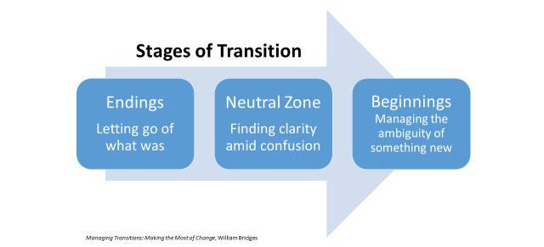

The work of Endings is letting go of the way things have been, including acknowledging what will end and what will be retained in the new.

The work of the Neutral Zone is finding clarity amid confusion. This is the space between the old familiar way and the future state. It is filled with both danger and opportunity. It feels like being between trapezes, where there is nothing to hold onto.

The work of Beginnings is managing the ambiguity of starting something new. It requires understanding why the old way had to change, having a picture in mind of the future state, a plan for getting there, and a role in the new state.

Change Management Toolkit

23 | P a g e

Change Process Model (Kubler-Ross)

Another way to understand change is Elizabeth Kubler-Ross’ Grief Cycle Model (1969) illustrated here. This model, originally used to explain an individual’s bereavement change journey, is also widely used to explain the emotional responses people experience during other forms of change.
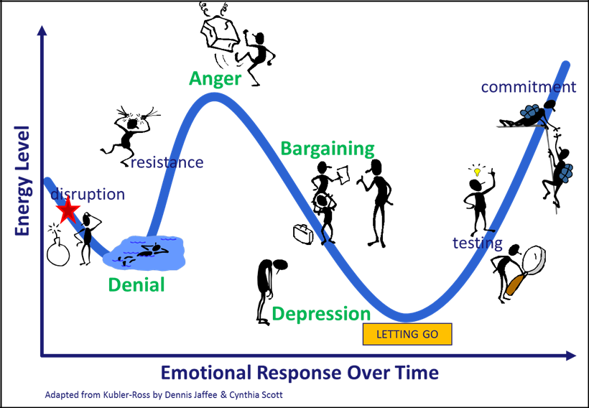

The model identifies an individual’s emotional journey over time. As a leader, you must support people differently at each of the different emotional stages. The stages of change are...

- Denial

- Anger

- Bargaining

- Depression

- Acceptance

While the journey appears sequential, in real life people move through the stages at different rates. Some individuals go through the stages in a rather linear fashion. They seem to zip right though the resistance parts of the journey, moving rather quickly straight to acceptance.

Others may get stuck for a period of time at a particular stage. They have trouble “letting go” causing them to get stalled along the way.

When multiple changes are staggered or simultaneously occur in an organization during a short period of time, it is not uncommon for an individual to revert back to an earlier stage as the next wave of change hits.

Interestingly, all individuals tend to go through the same emotional journey whether they perceive the change as a positive (something they’ve chosen) or as a negative (something that has been thrust upon them). People often wish they could skip the resistance part of the journey; they can’t. They must go through each of the stages in order to let go of the past and move forward into the future.

Change Management Toolkit

24 | P a g e

Change Process Model – Indicators & Strategies (Kubler-Ross)

As a leader, you will notice your employees moving through the stages of change at different rates. To set your team up for success, it will be necessary to be attentive to the emotional stage each individual is experiencing and adjust your support accordingly. In addition to being a resource for your team, you will want to use the strategies below to provide support yourself as well.

Listed below are behavioral indicators along with various strategies to use at each stage to help you generate a plan to provide individual support. Recognizing and proactively responding to the needs of each employee at each stage will help mitigate resistance and provide momentum to move employees forward through the change journey.

Denial Stage

You See:

- Indifference

- Disbelief

- Going through the motions

- Avoidance/Withdrawal

You Hear:


- Silence

- “It’s OK”

- “It will never happen”

- “It won’t affect me”
- “All we need to do is…”

Strategies:

- Provide frequent, consistent information about the change; explain what to expect and actions to adjust
- Clarify what is changing and what is not

- Place change in broader context
- Address rumors and misinformation; confront without threatening

Resistance (Anger/Bargaining/Depression) Stage

You See:

- Anger/Hostility

- Complaining

- Glorifying Past

- Skepticism

- Accidents

- Lack of concentration


You Hear:

- It’s unfair”

- “It doesn’t make sense”

- “I’m leaving”

- Asking for more detail

Strategies:

- Acknowledge and legitimize feelings, don’t justify the need for change now

- Clarify case for change

- When old issues resurface, don’t choke or punish them

- Give more information about the change; tell people where they stand

- Establish firm expectations

- Determine knowledge/skill gaps to prepare for the change

- Provide exposure and opportunity to influence participation



Adapted from Kubler-Ross by Dennis Jaffee & Cynthia Scott

Change Management Toolkit

25 | P a g e

The Change Process – Indicators & Strategies (Kubler-Ross), cont.

Testing Stage



You See: |  | Strategies:
• | Exploring options | • Focus on short –term goals and priorities
• | Risk-taking | • Encourage personal stock-taking and goal
• | Tentativeness |  | setting, and exploring options
• | Impatience | • | Encourage risk-taking
• | Activity without Focus | • Encourage new skills to be acquired
You Hear: |  | • | Reinforce desired behaviors
 |  | • Celebrate successes and endings
• | Enthusiasm | • Provide opportunities for participation and
• | Optimism |  | contribution
• “I’ve got an idea” |  | • Acknowledge efforts and the struggle

- “Let’s try…”

- “What if…

Acceptance Stage

You See: |  | Strategies:
• Acceptance of the change |  | • | Provide guidance, support, and recognition
• | Future orientation | • | Provide frequent feedback on progress
• | Initiative | • | Establish “performance levers” to sustain
• | Self-efficacy |  | new behavior
• | Confidence | • | Provide leadership: less information, more
You Hear: |  |  | inspiration
 |  | • | Be careful not to overload or burnout
• “How can I contribute?” |  | • | Enroll as advocate to assist others

- “Let’s get on with it”

- “We can do it even better”

- “I’m prepared whatever comes up”

Adapted from Dennis Jaffee & Cynthia Scott by Ewins & Winby

Change Management Toolkit

26 | P a g e

Core Values Exercise

One way to effectively manage resistance to change is to tap back into your own core values and find a way to anchor one or more of them to some aspect of the change. At the time a change is announced, the Core Values Exercise tool may be used proactively to create emotional resonance and assist you in supporting the change from a place of authenticity. If the change is already underway, the tool may be used reactively to help you mitigate internal resistance and continue moving you forward through the change journey.

For example:

- If one of your Core Values is Creativity, and you believe the change will bring you more opportunities to be creative in your job (doing less repetitive/routine work) then this would contribute to you supporting the change.
- If one of your Core Values is Responsibility, you may be able to tie supporting the change efforts to what it means to you to be “responsible” at work, and be able to support the change authentically from that perspective.

Circle your top 5 values from the list below. Add any that are missing that are meaningful to you.

Authenticity Harmony

Balance Health

Commitment Honesty

Compassion Humor

Concern for others Integrity

Courage Intelligence

Creativity Joyfulness

Education Kindness

Empathy Knowledge

Excellence Loyalty

Fairness Openness

Faith Perseverance

Family Personal growth

Freedom Respect for others

Friendship Responsibility

Fun Security

Generosity Serenity

Genuineness Service to others

Happiness Success

__________________________ __________________________

Looking at your identified core values, can you align one or more to the change? If so, how?

__________________________________________________________________________________________________

__________________________________________________________________________________________________

__________________________________________________________________________________________________

__________________________________________________________________________________________________

Change Management Toolkit

27 | P a g e

Best Practices for Leading Change – What to Do

Provide information, what you know, what you don’t, when to expect updates. – Employees need all available information to make realistic assessments and effective plans. Share what information you have when you have it: what is changing, what is not, what is known, what is unknown, when to expect updates.

Display a positive attitude – As the leader, you are in a positon of great influence. In a sense you are your team’s North Star. Even if you are not yet fully onboard with the change, display to your team an attitude that is unbiased and welcoming of feedback.

Stay connected to your team – Focus on team goals, foster support, monitor functioning, and celebrate achievements.

Re-recruit people – Reiterate to each team member their value, and your desire to have them remain on the team and support the change.

Surface issues and concerns – Show empathy; help employees reframe their personal response to the change so they can effectively manage their own personal resistance

Provide more structure – Define short-term objectives, time frames, priorities, and standards to help your team regain its equilibrium

Protect quality and customer service – Service standards must remain high.

Delegate – Continue delegating work tasks while remaining mindful of each employee’s emotional stage and providing them relevant support.

Empower – As appropriate, give employees more influence in day to day decisions. Determine the appropriate level of authority to assign by considering an employee’s current emotional stage, level of experience, capability, and the task itself.

Raise the bar – Provide challenging assignments and coach employees to grow and develop their skills

Recognition – During change it is especially important to show appreciation and provide acknowledgement for work well done.

2-way communication – Be honest about what you can’t say or don’t know, and be open to hearing feedback.

Inform/update higher management – Provide candid feedback on the change as it relates to the work and its impact on the people. This ensures leadership has the information needed to make informed decisions

Practice the 4 Vs:

This is not a change strategy by itself, rather a piece of a larger strategy, or a tool, to use at the very moment the change goes live.

- Visibility – Be visible, available and interested in your employees during this time. Brief check-ins will leave employees feeling supported and valued.

- Variability – Allow for varying personal reactions (see Kubler-Ross grief cycle model, pages 17-19) and give employees more flexibility at work to take care of themselves.

- Ventilation – allow opportunities (both formal and informal) for employees to tell their stories, compare their reactions, and express their feelings. Productivity may decrease initially; however, allowing ventilation can expedite getting back to a focus on work.
- Validation – say thank you and acknowledge employees for their contributions. Special recognitions and verbal encouragements go a long way in challenging times.

Adapted from Ewins & Windby

Change Management Toolkit

28 | P a g e

Best Practices for Leading Change – What NOT to Do

Don’t censor information or hold back until everything is known

Employees need all available information to make realistic assessments and effective plans. Share what information you do have, when you have it even if the information you have is not complete.

Don’t express cynicism

Employees look to you as a role model and need your support and constructive guidance.

Don’t be unrealistically positive

Don’t be Pollyanna… acknowledge when things are difficult.

Don’t isolate yourself

Employees need access to you to feel supported. Use employees’ cues to know when to become more involved and when to back off.

Don’t expect employees to all react the same way at the same time

Employees respond to the same situation differently (see Kubler-Ross grief cycle model, pages 17-19).

Don’t enable resistance

Enabling is an action you take that protects the employee from consequences of his/her actions and actually helps the employee to not move through the change process. Examples of enabling include:

- Covering Up

Providing alibis, making excuses or even doing someone’s work for them rather than confronting the issue that they are not meeting expectations.
- Rationalizing

Developing reasons why the person’s behavior is understandable or acceptable.

- Withdrawing/Avoiding

Avoiding contact with the person whose behavior is problematic.

- Blaming

Blaming yourself for the person’s continued challenging behavior or getting angry at the individual for not trying hard enough to improve their behavior or to get help.
- Controlling

Taking responsibility for the person by significantly changing their environment or trying to minimize the impact by moving them to a less important job.
- Threatening
Saying that you will take action (i.e. formal disciplinary action) if the employee doesn’t improve, but not following through.

Change Management Toolkit

29 | P a g e

Develop Change Plan
To Change Behavior – Shape the Path

Implementation Strategies

Risk Assessment Template

Success Metrics Overview

Success Metrics Template

Feedback Strategy Overview

Feedback Strategy Options

Change Communications Plan Overview

Change Communications Plan Template

Change Communication Brief Template

Change Management Toolkit

30 | P a g e
To Change Behavior – Shape the Path

To direct the Rider and motivate the Elephant, it is important to shape the Path by focusing the situation and its surrounding environment. Without a specific plan there is no clear path to get things done. Being specific narrows the focus, so the Elephant and the Rider are more likely to stay traveling together toward the goal. Often, what looks like
resistance is actually lack of direction.

Ways to Shape the Path – Make the Required Changes Specific

Tweak the Environment

What looks like a person problem is often a situation problem. Simple environmental tweaks may make the journey easier which can lead to dramatic behavioral changes because less self-control is required to achieve the result. Take a look at the situation and determine ways to make the right behaviors a little bit easier (those that support the change) and the wrong behaviors a little bit harder (those that maintain the status-quo).

Build Habits

Think of habits as behavioral autopilot. Habits allow behaviors to happen without the Rider having to take charge and exert self-control. Since self- control is an exhaustible resource, the more behaviors that can occur without tapping into it the better. Behavioral habits can be stitched into the environment through the use of action triggers. An action trigger initiates a preloaded decision to engage in a certain behavior. When people pre-decide, they turn the control of their behavior over to the environment, and an instant habit is created.

One type of action trigger is linking two behaviors together. For example, a person who drinks coffee each morning can connect this behavior to writing a to-do-list for the day. A more elaborate action trigger is the use of a checklist. It educates the Rider on what’s best and indicates the ironclad right way to do something. In complex environments, it can help individuals avoid blind spots and provide insurance against over confidence that can lead to mistakes.

Rally the Herd

In ambiguous situations, individuals look to other people for cues about how to behave. People are incredibly sensitive to the norms and expectations of the communities they are in, and instinctively try to fit in with their peer group. The Elephant looks to the herd for cues about how to behave especially in unfamiliar or ambiguous situations. Because behavior is contagious, publicize situations where the herd has embraced the right behavior and intentionally create language to articulate what is different and better about the change. These steps will serve to unleash the change by rallying the support of early adopters in swaying others in the community to get on board.

CALL TO ACTION

Use all of the templates and tools provided in this section (Develop Change Plan) to shape the Path in relation to your change initiative.

Heath, Chip, and Dan Heath. Switch: How to Change Things When Change Is Hard. Thorndike Press, 2011

Change Management Toolkit

31 | P a g e

Implementation Strategies

When implementing change there are three strategies to consider: Pilot, Big Bang, or Phased Big Bang.

Pilot: Choose a Pilot implementation, if you are testing a new innovative idea, possible growth strategy, or very risky core business operation. By implementing a pilot this will help the project team to analyze results, determine ROI and identify areas of risk and/or improvement before a full implementation roll-out. Ultimately, the reason for pilot testing is to test quickly and iterate as necessary.

Big Bang: Choose a Big Bang implementation for initiatives that align to strategic business priorities driven from the highest levels of leadership. A Big Bang is best used for rolling out a new system or strategy that requires campus-wide adoption and is effective immediately. The implementation typically occurs all at once, and mass communications are used to update and inform employees.

Phased Big Bang: A Phased Big Bang approach is used to chunk the implementation roll-out into cohorts. This approach aims to reduce operational risks associated with ramp up time or scalability and gives the project team the opportunity to iron out any difficulties identified. Groups who are selected for the first cohort must be willing to provide necessary feedback and be strong adopters of the strategy. As each new cohort rolls-out, implementation is expected to get easier as it gains more positive employee traction.

Example:

Cohort 1: Roll-out – January 1

Cohort 2 Roll-out - March 1

Cohort 3 Roll-out – June 1

Characteristics of each Strategy

 |  | Pilot |  |  | Big Bang & Phased Big Bang
Timeframe |  | Lasts less than 3 months |  |  | More than 3 months
How long will this project run? |  | Lasts less than 3 months |  |  | More than 3 months
Risk |  | Low Risk |  |  | High Risk
Associated risk of execution |  | Low Risk |  |  | High Risk
Cost |  | High initial cost |  |  | Low cost over time
Capital cost, 3rd party resources etc. |  | High initial cost |  |  | Low cost over time
ROI |  | Volatile return |  |  | Faster return
Return on Investment |  | Volatile return |  |  | Faster return
Disruption to Operations |  | Minimal; However employees may lack |  |  | Moderate; Organization will need ramp-
Ramp-up period, CM etc. |  | buy-in to test |  |  | up time
Next Steps for Implementation |  | Requires go/no-go decision |  |  | Always a “go” decision; with
Go forward as-is or iterate |  | Requires go/no-go decision |  |  | Sponsor approval

Change Management Toolkit

32 | P a g e

Risk Assessment Template

The purpose of risk assessment is to identify potential problems before they occur. This is to ensure risk mitigation activities can be planned and implemented as needed across the lifecycle of the change initiative. Use the following Risk Assessment Template to identify and address any issues that may hinder the projects desired outcomes.

How to use the Risk Assessment Template:

- List and describe the risk associated with the change initiative

- Indicate the risk category:
- Compliance - Adheres to laws, regulations, and policies

  - Efficiency – Proficiently achieving the objectives of the process o Financial – Efficient stewardship of funds

o Health & Safety – Promotes a healthy community and safe working environment o Information – Supports accuracy and reliability of data
o Operational – Productive use of resources o Reputational – Impacts university’s brand

o Security – Protect and secure information to prevent exploitation, corruption, or loss of data
  - Strategic – Supports a campus, unit, or collaboration level objective

- Use the below Risk Assessment Matrix to identify the appropriate risk approach
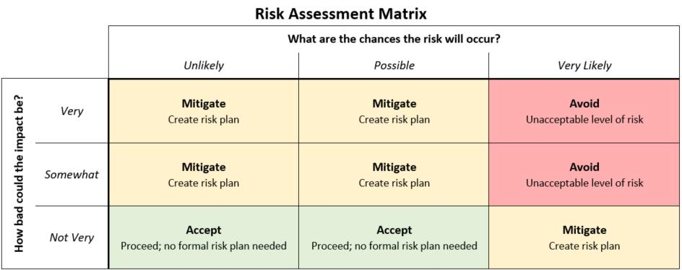

- For each risk identified with an approach of either Mitigate or Avoid indicate how the risk will be addressed

Change Management Toolkit

33 | P a g e

Risk Assessment Template, cont.

1. Risk Description | 2. Risk Category | 3. Risk Approach | 4. Risk Plan
Sample:
Vendors used for roll-out of change | Compliance | Avoid | Ensure vendors’ contracting terms
intiative may violate U.S. federal laws |  |  | include UCB’s right to monitor and audit
and regulations

Change Management Toolkit

34 | P a g e

Success Metrics Overview

When implementing a change in the workplace, it is imperative to have success metrics. Success metrics can be defined as the metrics that help leadership to assess the overall health and achievement of the change. Success metrics are useful across all levels of the organization as they evaluate, indicate, and measure performance based on the objectives set forth by the change initiative. From a leadership standpoint, they help leaders understand the initiatives overall impact. Many of these metrics include specifics on how many employees are affected and how the change has impacted their engagement.

The below graphic shows the cycle of determining and tracking success metrics for the change initiative.


5. Communicate | 1. Design success
and share | 1. Design success
and share | metrics strategy
findings | metrics strategy

4. Adjust
success metrics _{2. Collect data strategy}

(if needed)

3. Analyze data

Success Metrics are quantitative data obtained from:

- Customer Satisfaction

- Financial Performance (e.g. cost, revenue)

- Operational Performance (e.g. rework, lead time, handoffs)

- Product and/or Service Quality (e.g. quality, defects, volume, frequency)
- Public Outreach (e.g. number of people impacted)

- Supplier Performance (e.g. reliability, durability)

Feedback is qualitative data obtained from:

- 1:1 Meetings

- Team Meetings

- Focus Groups

- Surveys

- Open Comment Box (Live URL available 24/7)

- Incentivized feedback

Success metrics and feedback are used to understand the current
landscape of the change effort through all stages of the initiative. Quantitative data can be disseminated via metrics reporting.

Qualitative data must be combined and grouped into common themes in order to bubble up relevant information. For transparency,

all impacted employees must be provided the outcome of the metrics and feedback provided to leadership.

- Pre-Implementation – gather success metrics

Use the time before implementation occurs to hypothesize possible success metrics tied to the change objectives. These metrics should be defined before Day 1 of the Pilot, Big Bang, or Phased Big Bang kick-off.

- Implementation – Pilot, Big Bang, or Phased Big Bang Kick-off

The first three months is the learning curve period. During this time, expect many of the metrics to be volatile. Typically, after 3 months the data will start to normalize and a true pattern of the strategy’s performance will emerge.

- Post Implementation – monitor, control success, and promote continuous improvement

By the end of the testing period the change strategy should now be evergreen in your department. To ensure its continued success, monitor and keep all success metrics visible to the users at hand. Update these metrics with a particular cadence (weekly, bi-weekly, etc) and have conversations around achievements or improvement opportunities as they arise throughout the year. Refer to Monitor Metrics for Continuous Improvement.

Employees have a responsibility to the campus to be accountable for the changes made year over year. Ongoing monitoring of metrics ensures a feedback loop for continuous improvement. This feedback helps leadership to understand that no one process is forever optimal. By maintaining the conversation of metrics, we can collectively celebrate success while continually exploring improvements together.

Change Management Toolkit

35 | P a g e

Success Metrics Template

Determine the metrics that speak to the change initiatives objectives and are critical to sustaining success.

 | What is changing? |  |  | What is the measure? |  |  | Success metrics |  |  | Currently exists as |  |  | Data owner? |  |  | Frequency
 | What is changing? |  |  | What is the measure? |  |  | data category |  |  | a metric? (Y/N) |  |  | Data owner? |  |  | (Wkly, Mnthly etc.)

Success Metrics Data Categories:

Financial Performance | Operational Performance | Product and/or Service Quality
(e.g. cost, revenue) | (e.g. rework, lead time, handoffs) | (e.g. quality, defects, volume, frequency)
Customer Satisfaction | Public Outreach | Supplier Performance
Customer Satisfaction | (e.g. number of people impacted) | (e.g. reliability, durability)

Change Management Toolkit

36 | P a g e

Feedback Strategy Overview

When implementing a change, create a feedback strategy for each phase of the change:


Pre-implementation – used to understand existing concerns


Implementation – illustrates how the implemented change immediately impacted the identified concerns and helps determine if iteration is necessary


Post-implementation – used to monitor and control the implemented change and fosters continuous improvement

The data collected in each phase allows the Project Team to understand the successes and ongoing opportunities of the roll-out. This information is communicated to the Leadership Team to enable informed decisions. The following graphic illustrates the elements of the feedback strategy.
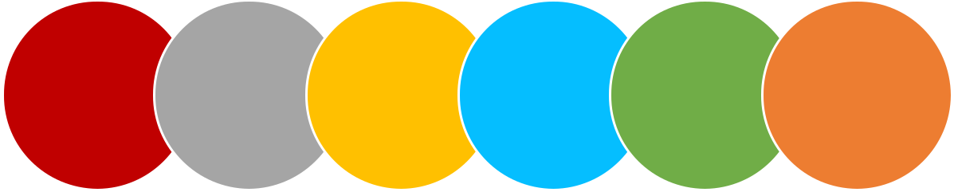

Choose | Implement |  | Synthesize
Choose | Chosen | Collect Data | Synthesize | Share | Create Action
Feedback | Strategy | Collect Data | and Analyze | Share | Create Action
 |  |  |  | Information | Items
Strategy | (pre-imp, imp, |  | Data | Information | Items
 | post-imp)

Change Management Toolkit

37 | P a g e

Feedback Strategy Options

When obtaining feedback there are various self-service or in-person methods to choose from. Use the tables below to select the strategies that best apply:

Self-Service Feedback Strategies

 |  | Description | Advantages |  | Pre-Implementation |  |  | Implementation |  |  | Post-Implementation
 |  | Surveys/User Polls (Survey Monkey, Qualtrics, etc.)
 |  | Used to obtain the overall pulse of the change. It | • easy to use
 |  | is best to use no more than four surveys during | • easy to use |  | 1 survey to understand |  |  | 1 pulse survey sent one |  |  | Used periodically for
 |  | is best to use no more than four surveys during | • reach large numbers of |  | 1 survey to understand |  |  | 1 pulse survey sent one |  |  | Used periodically for
 |  | the lifecycle of the project to avoid survey | • reach large numbers of |  | 1 survey to understand |  |  | 1 pulse survey sent one |  |  | Used periodically for
 |  | the lifecycle of the project to avoid survey | people |  | current state |  |  | week after go-live date |  |  | continuous improvement
 |  | fatigue. | people |  | current state |  |  | week after go-live date |  |  | continuous improvement
 |  | fatigue. | • anonymous (optional)
 |  | (requires vetting of questions and testing of tool | • anonymous (optional)
 |  | selected prior to use)
 |  | Open Comment Box
 |  | An open text box that lives on a dedicated | • live URL available 24/7
 |  | project specific web page or a department’s | • live URL available 24/7
 |  | project specific web page or a department’s | • anonymous (optional) |  |  |  |  | Ongoing throughout |  |  | Ongoing for continuous
 |  | intranet. This mechanism is best suited for post- | • anonymous (optional) |  | n/a |  |  | Ongoing throughout |  |  | Ongoing for continuous
 |  | intranet. This mechanism is best suited for post- | • may leave open |  | n/a |  |  | Ongoing throughout |  |  | Ongoing for continuous
 |  | implementation where the feedback goes | • may leave open |  | n/a |  |  | implementation period |  |  | improvement purposes
 |  | implementation where the feedback goes | indefinitely for ongoing |  |  |  |  | implementation period |  |  | improvement purposes
 |  | directly to the process owner for continuous | indefinitely for ongoing
 |  | directly to the process owner for continuous | input
 |  | improvement. | input
 |  | (may require ongoing monitoring)
 |  | Incentivized Feedback | • elicits
 |  | Use work appropriate incentives to increase | • creates excitement
 |  | feedback participation (e.g. raffle, gift cards, | that increases |  | n/a |  |  | n/a |  |  | Collect feedback over 2-
 |  | event tickets, etc.). | individual participation |  | n/a |  |  | n/a |  |  | weeks
 |  | (consider any potential impact the incentive may | and leads to word of
 |  | have on the data being collected) | mouth marketing
 |  | 1:1 Meetings
 |  | Utilize 1:1 meetings to learn how the change is | • comfortable setting |  |  |  |  |  |  |  | Discussion topic at each
 |  | being received | • comfortable setting |  | Discussion topic at each |  |  | Discussion topic at each |  |  | Discussion topic at each
 |  | being received | • enables vulnerability |  | Discussion topic at each |  |  | Discussion topic at each |  |  | Discussion topic at each
 |  | (requires safety and trust) | • enables vulnerability |  | Discussion topic at each |  |  | Discussion topic at each |  |  | 1:1 meeting until change
 |  | (requires safety and trust) | • gathers individual in- |  | 1:1 meeting |  |  | 1:1 meeting |  |  | 1:1 meeting until change
 |  |  | • gathers individual in- |  | 1:1 meeting |  |  | 1:1 meeting |  |  | fully realized
 |  |  | depth feedback |  |  |  |  |  |  |  | fully realized




Change Management Toolkit

38 | P a g e

Feedback Strategy Options, cont.

In-Person Feedback Strategies

 | Description | Advantages |  | Pre-Implementation |  |  | Implementation |  |  | Post-Implementation
 | Team Meetings |  |  | 2-3 meetings to |  |  | Bi-weekly meetings to |  |  | 2-3 meetings to
 | Allows employees to surface feedback on the |  |  | 2-3 meetings to |  |  | Bi-weekly meetings to |  |  | 2-3 meetings to
 | Allows employees to surface feedback on the | • creates transparency |  | 2-3 meetings to |  |  | collect/share information |  |  | 2-3 meetings to
 | change in their current team environment. | • creates transparency |  | collect/share |  |  | collect/share information |  |  | collect/share
 | change in their current team environment. | • raises group issues |  | collect/share |  |  | throughout |  |  | collect/share
 | (requires strong facilitator) | • raises group issues |  | information |  |  | throughout |  |  | information
 | (requires strong facilitator) |  |  | information |  |  | implementation period |  |  | information
 | Focus Groups (5-12 participants) | • shared experience
 | Focus Groups (5-12 participants) | • participants react
 | Allows the Project Team to solicit specific feedback | • participants react
 | Allows the Project Team to solicit specific feedback | together and build off
 | from key contributors. | together and build off |  | 1-5 sessions |  |  | n/a |  |  | n/a
 | from key contributors. | of each other’s |  | 1-5 sessions |  |  | n/a |  |  | n/a
 | (requires strong facilitator and real-time | of each other’s |  | 1-5 sessions |  |  | n/a |  |  | n/a
 | (requires strong facilitator and real-time | comments
 | transparency of information captured) | comments
 | transparency of information captured) | • option to curate
 |  | audience
 | Townhalls | • reach large numbers
 | Use to summarize findings, celebrate successes, and | • reach large numbers |  |  |  |  |  |  |  | 1 – 2 meetings to
 | Use to summarize findings, celebrate successes, and | of people |  | 1 – 2 meetings to |  |  |  |  |  | 1 – 2 meetings to
 | address opportunities related to the change across | of people |  | 1 – 2 meetings to |  |  |  |  |  | 1 – 2 meetings to
 | address opportunities related to the change across | • creates transparency |  | provide key |  |  | n/a |  |  | provide key
 | all key audiences | • creates transparency |  | provide key |  |  | n/a |  |  | provide key
 | all key audiences | • solicits community |  | information |  |  |  |  |  | information
 | (requires strong facilitator and prepared agenda) | • solicits community |  | information |  |  |  |  |  | information
 | (requires strong facilitator and prepared agenda) | input




Change Management Toolkit

39 | P a g e

Change Communications Plan Overview

The Change Communications Plan is a tool that provides the Change Manager with a high level messaging plan for informing important stakeholders throughout the lifecycle of a change project. These communications are used to create awareness and provide key information to keep stakeholders updated appropriately.

Messaging around a change is often complex. There can be numerous stakeholders with varying interests requiring messages to be framed differently. For this reason, it is important to have the right people in the room when drafting the Change Communications Plan to ensure a holistic approach when determining: the audience (who), messaging (what), and communication delivery method (how).

Work Session Participants:

- Change Manager

- Project Manager

- Project Leadership Team (Sponsor, Project Leads, Process Owners, etc.)

Work Session Format:

- 2-Hr Meeting (add additional meetings if needed) o Include all required participants

- Edit Process Improvement Communications Plan in real-time o LCD Projector & Laptop
o Project Process Improvement Communications Plan template (see Pages 35-38)

Instructions for Change Communications Plan Template:

- Using the provided template, work session participants will complete Sections 1 & 2 together to the best of their ability. Keep in mind this is a working document and additional items can be check marked throughout the working session.

- Begin to complete Section 3 by referring to the first identified audience in Section 1 and complete the template for all messages related to that particular audience.
- Continue to follow Step 2 until all audiences have been addressed in the Section 3’s plan.
- Once complete, the Communications Plan is managed and owned by the Change Manager and/or the Communications Leads who will ensure the execution of these messages.

Instructions for Change Communications Brief Template:

There are often numerous stakeholders with varying interests that require messages about the change initiative to be framed differently. The Change Manager will use the completed Change Communications Plan to create Change Communications Briefs for each determined communication.

Often in small to medium sized change initiatives, the Change Manager is expected to craft the messaging themselves.
Use the Change Communications Brief Template as a thinking tool to outline your messages.

In the event that you are able to partner with a Communications Specialist, provide the completed Change Communications Brief Templates to them for reference as they prepare messaging for you.

Change Management Toolkit

40 | P a g e

Change Communications Plan Template

Project Title: ________________________________________________________________________________

Project Description:

Combine Case for Change and Compelling Vision wording obtained from Project Charter.

SECTION 1: Determine Stakeholders

Read through the list of Stakeholders below and place a checkmark next to any that will require messaging for your project

CAMPUS LEADERSHIP | FACULTY | OFF CAMPUS STAKEHOLDERS
☐ Vice Chancellors | ☐ Council of Deans | ☐ Donors
☐ Chancellor’s Cabinet | ☐ Academic Senate | ☐ Cal Neighbors
 | ☐ The Berkeley Division Council (DIVCO) | ☐ Local Chamber of Commerce
 | ☐ Department Chairs | ☐ Local City Council
 |  | ☐ Other UC Campuses
STAFF | STUDENTS | ☐ Parents
☐ Chief Administrative Officers Group (CAO) | ☐ Associated Students of UC (ASUC) | ☐ State Legislatures
☐ Campus Advisory Groups | ☐ Graduate Assembly Leadership | ☐ UC Berkeley Alumni
☐ RAC Forum | ☐ Undergraduates | ☐ UCB Foundation
☐ HR Network | ☐ Graduate-Professional | ☐ UC Office of the President
 | ☐ Graduate-Academic | (UCOP)
 |  | ☐ UC Regents
 |  | ☐ Vendors

Change Management Toolkit

41 | P a g e

IDENTITY-BASED STAFF ORGANIZATIONS

- Alianza

- Asian Pacific American Systemwide Alliance (APASA)
- Berkeley Staff Assembly (BSA)

- Berkeley Veterans

- Black Staff & Faculty Organization (BSFO)

- Cal Women’s Network

- Chancellor’s Staff Advisory Committee (CSAC)

- Staff Alliance for Disability Access (SADA)

- LavenderCal

- Native American Staff Council (NASC)
COMMUNITIES OF PRACTICE

- Academic Business Officer Group (ABOG)

- AppNet

- Berkeley Events Network (BEN)

- Berkeley Facilitator’s Network (BFN)

- Business Process Analysis Working Group (BPAWG)

- Berkeley Research Administrator’s Group (BRAG)
- Cal Assessment Network (CAN)

- Campus User-Centered Design Group (UCD)

- Camps and Youth Programs on Campus (CYPC)

- Career Practitioner’s Community (CPC)
- Coalition for Education and Outreach (CEO)

- Cal Data Visualization Network (CDVN)

- Micronet

- Web Accessibility

- Webnet

OTHER INTERNAL STAKEHOLDERS

- Admissions

- Academic Advising

- BAIRS

- BFS

- CalAnswers

- CalCentral

- CalPlanning

- Cal Student Central

- CalTime

- CSS-IT

- Data Warehouse

- Environment Health and Safety (EHS)

- Financial Aid and Scholarship Office (FASO)

- General Accounting

- Graduate Education

- HCM

- Information Services and Technology (IST)

- Office of the CFO

- Office of the CIO

- Office of the Registrar

- Payroll

- PeopleSoft – infrastructure

- Student Affairs IT (SAIT)

- Student Technology Council (STC)

- Technology Program Office (TPO)

- Vice Chancellor of Administration & Finance (VCAF)

- Vice Chancellor of Equity & Inclusion (VCEI)

- Vice Chancellor of Research (VCR)

- Vice Chancellor of Student Affairs (VCSA)

- Vice Chancellor of Undergraduate Education (VCUE)

- Vice Chancellor of University Development & Alumni Relations (UDAR)

Change Management Toolkit

42 | P a g e

SECTION 2: Identify Channels of Communication

Check all tools that you are interested in using for your project communications. Most audiences require multiple communication channels to be reached effectively.

MESSAGING FROM EXECUTIVES | ELECTRONIC MEDIA | SOCIAL MEDIA
☐ Campus Leadership | ☐ Departmental Website | ☐ Instagram
☐ Project Leadership | ☐ Presentation Slide Deck | ☐ Facebook
 | ☐ Project Blog | ☐ LinkedIn
EMAIL | ☐ Project Website | ☐ Slack
☐ CalMessage (broadcast email) | ☐ Project WIKI | ☐ Snapchat
☐ CalMessage (subscription lists) | ☐ Sponsor/Partner Website | ☐ Twitter
☐ Other campus email lists | ☐ System Notifications | ☐ YouTube
 | ☐ Videos | ☐ Virtual Chat Rooms
 |  | ☐ Wisdom Café

EDUCATIONAL TOOLS | PUBLICATIONS | PRINT MEDIA
☐ FAQs | ☐ California Magazine (Alumni) | ☐ Banners
☐ Infographics | ☐ Daily Californian | ☐ Brochures
☐ Information Kits | ☐ The Berkeleyan | ☐ Fact Sheets
☐ Job Aids | ☐ The Graduate | ☐ Newsletters
☐ Training Manuals |  | ☐ Post Cards
☐ Training Workshops |  | ☐ Posters
MEETINGS | EVENTS | OBTAIN PRE/POST IMPLEMENTATION
☐ 1:1 | ☐ Project Launch | FEEDBACK
☐ Department Staff Meetings | ☐ Project Road Show | ☐ Surveys/User Polls
☐ Unit Staff Meetings | ☐ Town Hall Meetings | ☐ Open Comment Box
☐ Team Meetings |  | ☐ Incentivized Feedback
COMMUNITIES OF PRACTICE PRESENTATION | STAFF GROUP PRESENTATION | ☐ Focus Groups
☐ BPAWG | ☐ Chief Administrative Officers Group (CAO)
☐ CAN | ☐ RAC Forum
☐ BFN | ☐ HR Network
 | ☐ CSS Manager/Supervisor Forum
 |  | Change Management Toolkit

43 | P a g e

SECTION 3: Draft High Level Plan

Project Title: ___________________________________ Date Drafted/Revised: ______________________________

 | Audience |  |  | Message |  |  | Messenger |  |  | Method of
 | Audience |  |  | Message |  |  | Messenger |  |  | Communication |  |  | Communication Date
 | Who needs to know? |  |  | Message |  |  | Messenger |  |  | Communication |  |  | Communication Date
 | (See Section 1) |  |  | Information to communicate |  |  | Who should deliver the message? |  |  | How will the message be delivered?
 | (See Section 1) |  |  |  |  |  |  |  |  | (See Section 2)

Change Management Toolkit

44 | P a g e

 |  |  |  | Change Communication Brief Template
Name: |  |  |  |  | Project Title:
Email/phone: |  |  |  |  | Department:
Request Date: |  |  |  |  | Due Date::
Method of Communication:
Audience(s):

Main Message:

Required Message Details:

Call to Action (if applicable):

Strengths (check all that apply)

One or more of our key strengths should come through in the content of this communication.

☐ Conviction ☐ Excellence

☐ Scale ☐ Diversity

Additional Considerations (if any):

Mood (check one quadrant)

The atmosphere of the message can shift in many directions depending on what’s appropriate for the audience. Use the grid to indicate the right balance for your communication.

Formal


Tone (check all that apply)

Choosing from the specific traits below will help you communicate with a consistent voice.

☐ Curious ☐ Open

☐ Optimistic ☐ Influential

☐ Intense ☐ Independent

☐ Transparent ☐ Socially Conscious

Subtle

☐ ☐

☐ ☐

Casual

Bold

Change Management Toolkit

45 | P a g e

Implement & Monitor the Change
To Sustain the Change – Keep the Momentum Going Change Readiness Assessment (final check before pilot/big bang) Monitor Metrics for Continuous Improvement

Change Management Toolkit

46 | P a g e
To Sustain the Change – Keep the Momentum Going

When any forward movement towards the change is noticed, it must be reinforced. Look for bright spots, no matter how tiny, and reward them. Reinforcement of bright-spot behaviors creates a snowball effect. As people begin to act in a new way, and are recognized for this new behavior, it becomes increasingly difficult for them to dislike the way they are acting. As they act differently, they begin to think of themselves differently, and as their identity evolves, this

reinforces the new way of doing things. At some point, the momentum shifts from resisting the change to supporting it. This is how small changes, when reinforced, snowball into big changes.

CALL TO ACTION

Use all of the templates and tools provided in this section (Implement and Monitor the Change) to sustain the change and keep the momentum going.

Heath, Chip, and Dan Heath. Switch: How to Change Things When Change Is Hard. Thorndike Press, 2011.

Change Management Toolkit

47 | P a g e

Change Readiness Assessment (final check before pilot/big bang)
Use the below assessment to assess each team(s) and/or stakeholder(s) readiness for the change.

☐ Team : ___________________________ ☐ Stakeholder: ___________________________

 |  | Questions to Assess Change Readiness |  |  |  | Yes |  |  | Partial |  |  | No
 |  | (Awareness) Does your team or does your stakeholder understand…
 | 1. |  | the problems inherent in the current situation?
 | 2. |  | the opportunities that are being missed if the change doesn’t happen?
 | 3. |  | what is trying to be achieved?
 | 4. |  | how things will be better?
 | 5. |  | how the change will impact their area of work?
 | 6. |  | what their role will be in the future state?
 |  | (Desire) Does your team or does your stakeholder…
 | 1. |  | know that management is aligned with the change efforts?
 | 2. |  | feel their concerns, questions, and needs are being heard?
 | 3. |  | feel hopeful about the future?
 | 4. |  | see value in the change?
 | 5. |  | believe a well thought out strategy is being put in place to achieve the change?
 |  | (Knowledge) Does your team or does your stakeholder… (skills, informational, training)
 | 1. |  | have the necessary information, knowledge and skills to successfully fulfill their role?
 | 2. |  | know where to go for additional information about the change?
 | 3. |  | know what campus resources are available to support the personal side of change?
 | 4. |  | know what success looks like?
 | 5. |  | have a plan to achieve success?
 | 6. |  | know which behaviors will need to change?
 |  | (Ability) Does your team or does your stakeholder… infrastructure (systems, tools)
 | 1. |  | believe that the organization has provided appropriate resources (time, staff,
 |  |  | information, etc.) to support the anticipated change?
 | 2. |  | have the necessary systems, processes, and policies in place?
 | 3. |  | have the ability to execute the new behaviors required for the change?
 | 4. |  | know how to perform the required tasks?
 |  | (Reinforcement) Does your team or does your stakeholder…
 | 1. |  | view management as a resource for removing/overcoming barriers?
 | 2. |  | have mechanisms in place to reinforce the required behaviors?
 | 3. |  | have metrics in place to assess the ongoing effectiveness of the change?
 |  | Total
 |  |  |  |  |  |  |  |  | Change Management Toolkit

48 | P a g e

Monitor Metrics for Continuous Improvement


Once implementation occurs begin tracking the success metrics identified in the Success Metrics Template. At this point, these metrics are used to gauge a pulse on adoption, engagement, buy-in, and to obtain an overall reaction to the change. The Project Manager and Change Manager will collaborate

to create communications with a particular cadence that disseminates both the quantitative and qualitative data being tracked.

6. Communicate | 1. Use designed
changes made to | 1. Use designed
changes made to | success metrics
affected | success metrics
affected | strategy
stakeholders | strategy

The graphic to the right shows the cycle of how tracking success metrics contributes to a continuous improvement feedback loop.

For project transparency, ensure all impacted employees are also provided with a communication of the outcome of the metrics and feedback that are shared with leadership.

5. Iterate change | Continuous
intiative | Improvement | 2. Collect data
(if needed) | Feedback Loop

4. Share findings
with Project 3. Analyze data

Team

Success Metrics are quantitative data obtained from:

- Adoption rate

- User reach (e.g. number of people impacted)

- Speed of adoption

  - Number of exceptions made

- Financial Performance (e.g. cost, revenue)

- Customer Satisfaction

- Usage and utilization reports

  - Operational Performance (e.g. rework, lead time, handoffs)
- Product and/or Service Quality (e.g.

quality, defects, volume, frequency)

  - Supplier Performance (e.g. reliability, durability)

- Employee Engagement

  - Turnover rate (number of people leaving due to the change)

Feedback is qualitative data obtained from:

- Employee buy-in

  - 1:1 Meetings

  - Team Meetings

- Employee feedback

  - Focus Groups

  - Surveys

  - Open Comment Box (Live URL available 24/7)

  - Incentivized feedback

Change Management Toolkit

49 | P a g e

Leave page blank

Change Management Toolkit

50 | P a g e

